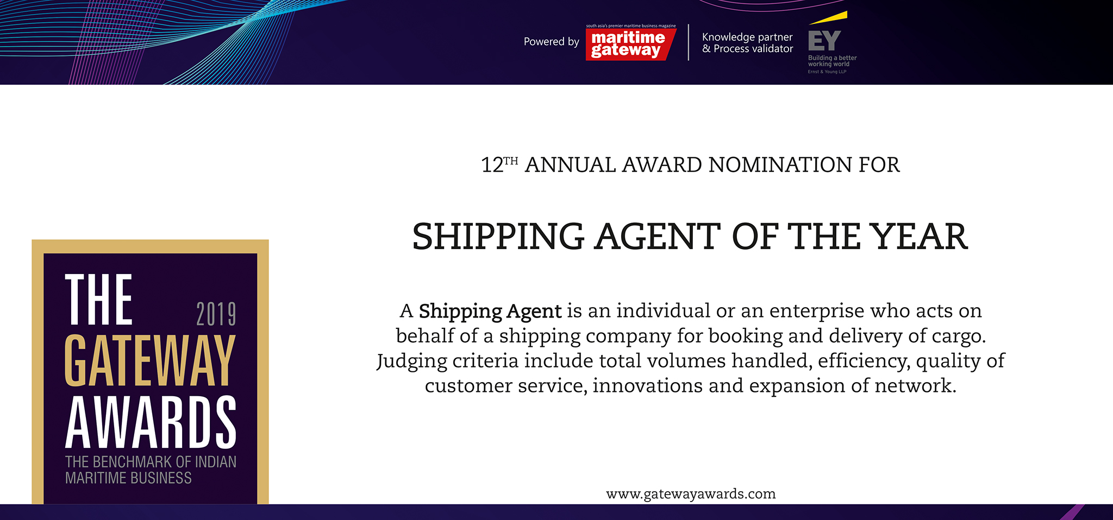

Please fill your responses and mail it to the address mentioned at the end of the Questionnaire

Note: All information and data should be provided for the FY 2018-19. In case, if you are unable to provide FY 2018-19 data, CY2018 information can be sent with a reason for not providing data for FY2018-19.
Name of the Organization

Contact Person

Designation

Contact no.

Official Email ID

Address

Contact information:

Performance and Operational Indicators

Parameters |  | Units | Inputs
Cargo volume by segment | Containerized cargo | Million TEUs
 | Non-containerized cargo | Million tonnes
Cargo volume Growth Y-O-Y by segment | Containerized cargo | Percent
 | Non-containerized  Cargo | Percent
Network reach | India | No. of offices
Infrastructure Enhancements

 |  |  | Existing | New additions in FY2018-19/CY18
No. of offices | @ Ports | Number
 | @ ICDs | Number
 | @ CFSs | Number

Innovations/ Investments/ Enhancements

Parameters | Type of inputs needed | Inputs
Innovations | • Qualitative inputs  • Word limit ~ 200 words.
Technology Enhancements

Investments made

Please use below contact for sending filled-in form and also for any queries.

Rakesh Oruganti | Cell: +91 99483 34568; E mail ID: rakesh.oruganti@gatewaymedia.in

